Sample Test Plan
ISO MANAGEMENT SYSTEM

Submitted by Team x
Revision History
Name | Date | Remarks | Version
Version 1 | 2014 | Released version | 1.0
Version 2 | 11/02/2015 | Test the requirements of new version | 2.0

1. Introduction
The Test plan has been created to communicate test framework and approach to team members. The main purpose of this test plan is that to ensure the ISO management system being developed and changed offers a high degree of quality before it’s delivered to customers. In the test plan delivers objectives, scope, schedule of tests, test case and procedure, and policy to handle failure. Testers will verify and validate all the functional requirements of the system by scenarios and further to judge whether they are passed or failed based on criteria. However, testers will take response actions to deal with the failed ones as well.
Software Project Overview
The software project is to develop a software product for chemical company which deals with Bromine transportation. The present version of the product consists of the container model for US branch. However, we need to enhance it by developing container model for UK branch. Make admin has the access to register the staff members, so in the registration process we need to add an attribute location based on which interface redirects to model based on the location. If Staff Member is from U.S. location we need to show U.S. Container interface on screen, and if he is from U.K. location we need to show U.K. Container interface on screen.
Use Cases of the Test
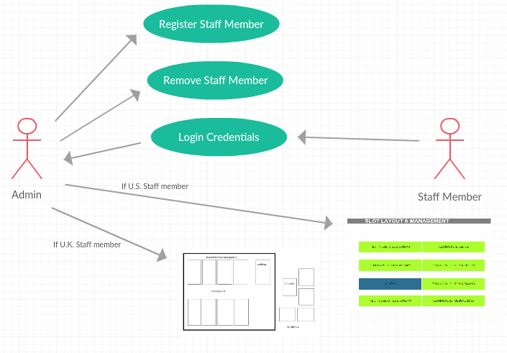

  - Objectives
Testers utilize test case to examine the functional requirements, they will set up some scenarios of the test for testing the features need to be tested. The tests include testing inputs, executing conditions and expected result, the test team is not only the tester but also the customer in the test plan, they are responsible to test the ISO Management Software and ensure it meets customer needs.
  - Test Approach
Functional and system testing
Opacity: black-box testing
Black-Box testing: testers validate the high level design and code what it is supposed to do of the test cases to meet customer requirements specification.
Functional testing: make sure that the specific functionalities meet the requirement specification works.
System testing: ensure the program work when the new program has been put in various environments for typical customer such as various version and different operation systems or application.
Performance testing: By specific performance to evaluate the acceptance of a system or component.

2. Scope
The Scope of the test plan has been divided to two parts which are feature to be tested that we emphasis and need to focus on; feature not to be tested which means the part of the existing project has been kept in the new project. Therefore, testers will only need to test the part of the changes and ensure that they are integrated well.
2.1 Features to Be Tested
- Admin registration in U.K./ U.S.
Make sure that admin can input information of staff includes set up user name and password then resister successfully with the address.

- Staff login in U.K./ U.S.
To validate when staff got the user name and password whether they can login depends on where they have been classified.
- User interfaces in U.K./ U.S.
Once the login successfully, the right interface is supposed to pop out on the screen directly depends on the locations.
- Each container of U.K.
To examine each container of U.K. has been developed correctly.
- New project on IOS/ Windows operation system.
Use system testing to make sure the new program can be used on IOS and windows operation system.

2. 2Features not to Be Tested
- Each container of U.S.
The container of U.S. of version 1.0 developers Dr. Box and team has been kept in the new project so that testers will not to test this feature.
2.3 Testing Tools and Environment
- Xampp
- Chrome Brower
- NetBeans IDE
- Bitbucket
- Git
2.4 Schedule of Tests
Task Name | Start | Finish | Effort | Comments
Test Planning | 10/30/2020 | 10/31/2020 | 2 Day | Complete
Review Requirements Documents | 11/1/2020 | 11/1/2020 | 1 Day | Complete
Create initial test estimates | 11/2/2020 | 11/3/2020 | 2 Day | Complete
Functional and system testing | 11/4/2020 | 11/8/2020 | 5 Day | Pending
Resolution of final failure and testing | 11/9/2020 | 11/13/2020 | 5 Day | Pending
Production to release | 11/13/2020 | 11/16/2020 | 4 Day | Pending
3. Test Cases and Procedures
3.1 Test Cast 1
Test Scenario: Checking admin registration in U.K./ U.S. functionality
Test Case: Ensure admin can create new unique user ID for new staff based on the locations, tester will validate the address such as U.K., U.S. and a blank or other random location.
Pre-conditions: The clicking of adding a member is valid
Test Steps: 1. Input the information of the new staff randomly and correctly
2. Create user ID and Password based on where the staff address
Test Data: Staff ID, first name and last name, username, e-mail, role, gender, mobile number, address and location
Expected Result: Admin can create new user ID with valid inputs for U.K. and U.S. staffs
Actual Result:
Severity: High
Pass/Fail:
Comment:

3.2 Test Cast 2
Test Scenario: Checking login in U.K./ U.S. functionality
Test Case: Checking the responses when login name and password entered are valid
Pre-conditions: Application must be installed; user must be registered
Test Steps: 1. Launch application
2. Enter login name
3. Enter password
4. Press login button
Test Data: Login name and Password
Expected Result: Login must be successful
Actual Result:
Severity: High
Pass/Fail:
Comment:

3.3 Test Cast 3
Test Scenario: Checking User interface in U.K./ U.S. functionality
Test Case: Check the right interface is supposed to pop out on the screen directly depends on U.K. and U.S.
Pre-conditions: Login successful
Test Steps: 1. Enter user ID has been created in U.K. and U.S.
2. Enter password
3. Press login button
Test Data: Login user ID of U.K./ U.S. staff and Password
Expected Result: The design must meet customer requirements
Actual Result:
Severity: High
Pass/Fail:
Comment

3.4 Test Cast 4
Test Scenario: Checking each container of U.K. functionality
Test Case: Validate the containers have been developed valid
Pre-conditions: U.K. interface shown on the main page
Test Steps: 1. Click each container
2. Identify whether they are worked or not
Test Data: Each container
Expected Result: Every container must be worked properly
Actual Result:
Severity: High
Pass/Fail:
Comment:

3.5 Test Cast 5
Test Scenario: Checking the new program on IOS/ Windows operation systems.
Test Case: Validate the new program can access on both operation systems
Pre-conditions: Application must be installed
Test Steps: 1. Launch application
2. Registration
3. Enter login and password then press login button
4. User interface shows correctly
5. Check each container
6. log out
Test Data: Applications, information of registration, user ID and password, user interface and containers.
Expected Result: New project can be used on both operation systems
Actual Result:
Severity: High
Pass/Fail:
Comment:

4.
Usecase | Test Objective | Precondition | Steps | Expected Result | Pass/fail | comment
5.5 | Verify the program chair is able to craft/update a curriculum | User muset be logged in as program chair | 1.User clicks "Enter Changes" | User clicks the button taking them to a page with options to create a new curriculum or edit an existing one.
 |  |  | 2.User selects to create new or edit existing curriculum | User clicks on one of two buttons. One taking them to curriculum creation, the other takes them to a list of curriculums they can edit.
 |  |  | 3.User fills in necessary infromation | User fills in the necessary info/changes
 |  |  | 4.User clicks "Submit" | Changes are saved
5.17 | Verify the user is able to view all advisors | User is logged in | 1. User selects "View All Advisors" from the main screen | User clicks "View All Advisors" button and it taken to page with all advisors listed.
 |  |  | 2. User selects whether or not to view a certain advisor. | User clicks on advisor, pulling up that advisors information.

5. Policy to Handle Failure
The policy to handle failure in the plan is that based on iterations of design, analyze, develop and test. When tester found failure, bug, issue, or task, tester needs to post the situations on Bitbucket which is a platform for manager, developer and tester to communicate. After developer measures the situations, developer will further to analyze and design then go through the unit test again. Once the problems have been solved, tester will use same scenarios as a standard to test the cases and judge whether the functionalities pass or fail again depends on criteria.

